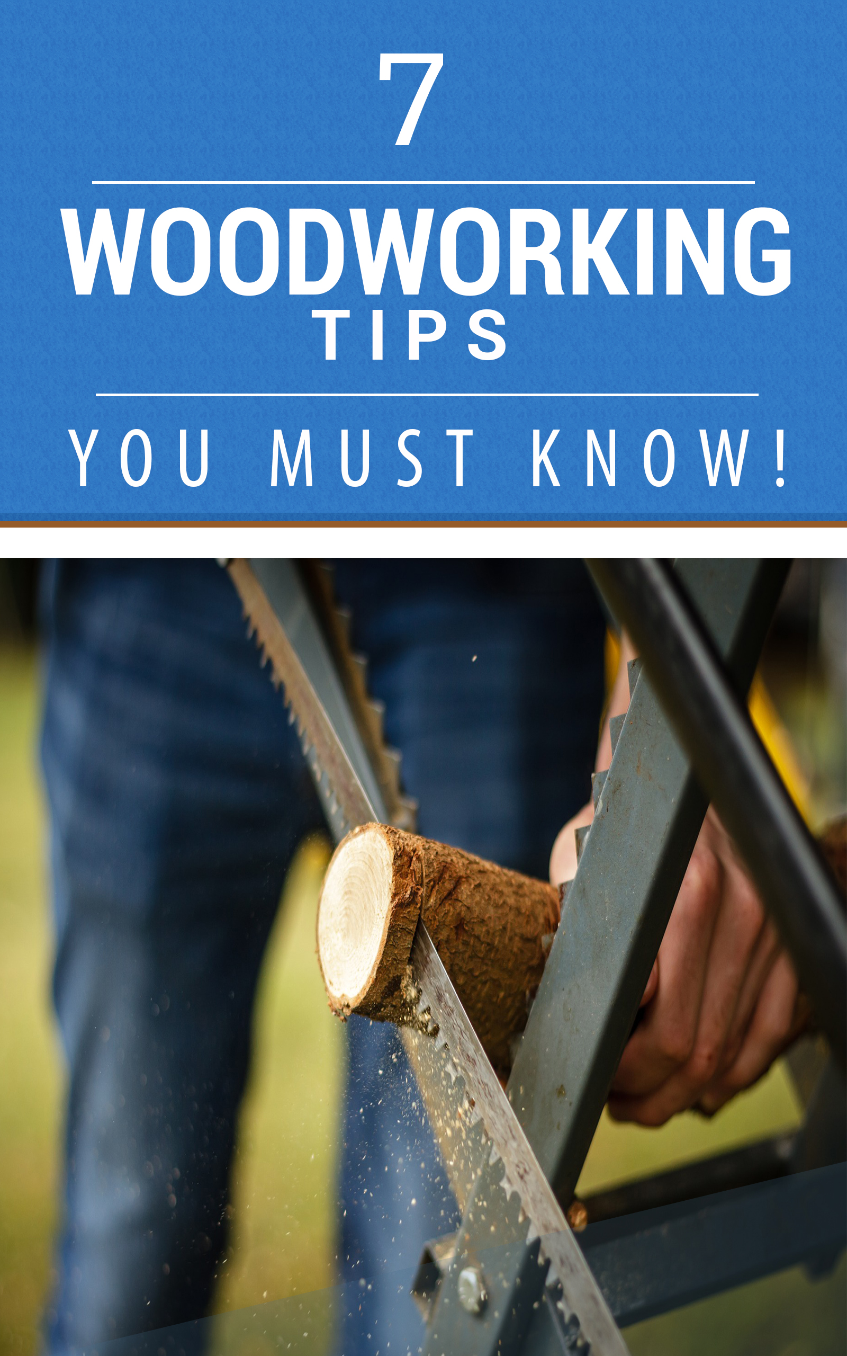

Copyright © 2017

All rights reserved. No part of this book may be reproduced, stored in a retrieval system, or transmitted in any form or by any means, electronic, mechanical, photocopying, recording, scanning, or otherwise, without the prior written permission of the publisher.

Disclaimer

All the material contained in this book is provided for educational and informational purposes only. No responsibility can be taken for any results or outcomes resulting from the use of this material.

While every attempt has been made to provide information that is both accurate and effective, the author does not assume any responsibility for the accuracy or use/misuse of this information.

You are encouraged to print this book for easy reading.

Use this information at your own risk.

Contents
What Is Woodworking 4
Tip #1 – Get the Basics Right 5
Tools 5
Use good plans 6
Plan before proceeding 7
Have a designated spot 7
Keep an eye on your budget 8
Take accurate measurements 9
Adopt safety measures 9
Tip #2 – Know What Tools You Need For Wood Carving 10
Chisel 11
Bench Knives 11
Gouge 11
Mallet 12
Coping saw 12
Tip #3 – Learn How To Bend Wood 13
Laminated Bending Wood 13
Steam Bending Wood 14
Microwave Bending Wood 14
Tip #4 – Build a Wood Lathe For Yourself 15
Tip #5 to #7 – Woodworking Safety Tips To Remember 15
Tip #5 – Wear safety equipment 16
Tip #6 – Power tools are not toys 17
Tip #7 – Work mindfully 18

What Is Woodworking

Woodworking has seen an increase in popularity over the past few years. In the past, woodworking which is actually a part of carpentry, was a norm. People built their own houses, patios, tables, furniture, etc. However, with modernization, now most of us just buy our furniture from IKEA or some other store.

Woodworking is catching on these days among thousands of enthusiasts because people are realizing that it is a cool way to be creative and there is a certain sense of pride and fulfilment that comes about from seeing something you have created that is beautiful and useful.

There is no end to what you can build if you have a good grasp of the fundamentals of woodworking. You could build sheds, chicken coops, garages and so much more.

What is most important is that you have the basic skills to work with the wood safely and efficiently. You will also need good plans to follow. Ideally, you should get your plans from a proven resource.

One good resource is Ted’s Woodworking Plans which contains over 15,000 woodworking plans. It also has a ton of woodworking tips and information to help you become a better woodworker. There’s something for everyone here. This is an online bestseller that has sold thousands and thousands of copies and it has helped more woodworking enthusiasts than any other product out there.

Tip #1 – Get the Basics Right

Tools
There’s a saying that goes, “A poor workman always quarrels with his tools.” While that is true, the fact remains that even a poor workman needs tools. If you want to be a good woodworker, not only do you need the right skills… but you also need the right tools.

The type of tools you pick will often depend on your skill level and temperament. Some people enjoy the process of manually working with their hands and taking time to create their masterpieces. Others want speed and efficiency so that they can get the job done quickly.

If you’re the type who likes speed, you may need to invest in power tools to speed up the process. If you’re the type who likes to do things slow, you can just stick to hand tools and whittle away at the wood. There is no right or wrong answer here.

Generally though, it would be a good idea for beginners to stick to hand tools so that they build their skills. Some woodworking skills are best executed with hand tools. So, it will be useful to not be totally dependent on power tools.

Use good plans
You can easily find a ton of woodworking plans online. However, many of them will not be good. The dimensions may be off or the instructions may be wrong. After all the effort, the finished product may not look like what you wanted it to look like. Usually, people blame themselves for this when in reality, the fault could lie with the inaccurate plans. You would be wise to choose one of Ted’s tested and proven Woodworking Plans and follow through with that.

Plan before proceeding
Once you decide on a plan, make sure you stay organized. Plan it well so that you have all the tools you will need for the project and also all the raw material to create the product. You must be well-prepared.

It’s best to get it all sorted out first instead of starting on a project and halfway realizing that you are lacking certain tools or there is a shortage of wood, etc.

Have a designated spot
Make sure you have one particular spot where you do your woodworking. It should be spacious enough for you to move around freely without obstruction. There should be good lighting, a safe area and your tools should be within easy reach.

Most people choose to either work in their garage or backyard. It’s not a good idea to do woodworking within your house because of the dust and wood shavings which will get all over the place and will probably make your spouse furious.

Keep an eye on your budget
Any experienced wood worker will know that woodworking will save you money but it isn’t necessarily cheap. While creating your own furniture may be cheaper than buying it, there are still expenses involved. You will need to purchase the raw material and maybe even a few tools.

So, plan it all out so that you start on a project that is within your means. You don’t want to end up in a situation where the project ends up halfway done because you don’t have the budget to buy more raw material. Knowing your budget will also allow you to shop around to get the best deal instead of just buying stuff blindly.

Take accurate measurements
Woodworking requires a certain degree of precision. This is especially true if you’re creating finger or dovetail joints. Make sure you take correct measurements and follow the plans to the letter. Attention to detail is crucial. One good practice will be to mark the wood so that you know where to cut or join, etc.

Adopt safety measures
This is a very, VERY important point. Many people have injured themselves during woodworking because they were careless or they did not practice good safety. Anytime you’re using power tools, you must be very alert and cautious.

You will need eye and ear protection. You may need to remove rings, chains or other jewelry that may get in the way. Make sure the blade on your power tool is well-secured and always disconnect the power when not in use. This topic of safety is so important that it will be covered in greater detail further down.

Tip #2 – Know What Tools You Need For Wood Carving
Wood carving is a technique where you create beautiful objects by whittling away at the wood. Unlike normal carpentry which involves sawing and hammering, wood carving is usually less strenuous and usually requires you to use a carving tool to shape the product.

There are several different types of carving tools that are used to do various tasks. Ideally, if you are a beginner, you should get a set of woodworking tools instead of buying them individually.

Expert woodworkers who are creating intricate products may spend more on specific tools to help them do the job better. The beginner who is just learning to carve wood will do fine with a basic set.

When buying a carving tool, do take note of the width of the cutting edge, the profile and also the shape. Let’s look at some of the common carving tools.

Chisel
Probably the most essential tool of the lot. The bevel-edged chisel is the most commonly used one and it’s highly popular among wood carving enthusiasts. The width of the blade and the shape of the cutting edge will determine the way you can use it for carving.

Bench Knives
These are used for tracing and scoring the patterns on the wood. This is a tool used for intricate work.

Gouge
A gouge is like a chisel but it’s used to make hollows within the wood. Depending on the gouge, the hollows can be deep or shallow. It is a very important tool that you absolutely MUST have.

Mallet
This is like a hammer but it’s used for woodworking. You will need a mallet to hit the chisel so that you can do your wood carving. This is an essential tool too.

Coping saw
You will need this saw to cut rounded corners and curves. Unlike normal saws which are usually large and unwieldy, coping saws are relatively small and best for intricate work.

Besides these tools, you will need several others like veiners, v-tools, fluters, rifflers, etc. While these may sound like objects from a Harry Potter book, they’re all woodworking tools that serve a variety of purposes.

Different woodworking plans will require different tools. So, know what you need and get them before you embark on your project. You may also wish to talk to the staff at the hardware store to help you make an informed buying decision.

Tip #3 – Learn How To Bend Wood
Knowing how to bend wood is a very useful skill to have. It’s also something that most laymen have no idea about. They often wonder how wood is bent to make canoes, bows, etc. The truth of the matter is that bending wood is an easy process if you know how to do it.

There are 3 most commonly used methods of bending wood, we’ll take a look at each one now.

Laminated Bending Wood
This is a very common method that is frequently used in furniture making. The way this method works is by gluing thin strips of wood, bending them and gluing them together. The thinner the wood, the easier it is to bend it. After the gluing, it is placed in a mold so that the wood holds its curved form. Once the glue dries, the wood will be curved.

Steam Bending Wood
Steam is used to bend wood with this method. It is probably the most commonly used method of bending wood and has been in practice since ancient times.

To use this method, you’ll need a steam box. The wood will be placed in a mold and there will be a hose that connects that connects it to another box containing water.

The water will be heated and the steam will make its way through hose and heat up the wood in the mold. With time, the heat will make the wood more pliable and it will bend. How fast this happens is dependent on the type of wood, its thickness and its age.

Microwave Bending Wood
This method is used by many woodworking beginners. It’s simple, it can be done at home and it’s effective.

You will need to wrap a wet towel around the wood that you wish to bend. Then place it in the microwave and heat it up for about 20 seconds. Depending on the heat and the moisture, you will be able to bend the wood quite easily after that. The only disadvantage here is that you can only use this for small projects because you are limited by the size of your microwave.

Tip #4 – Build a Wood Lathe For Yourself
A wood lathe is very useful for most woodworkers and you can easily build one yourself. This report is not going to go in-depth as to how you can create one because of the technical detail.

You can learn how to create one from Ted’s Woodworking Plans or you can do your research online and learn how to do it.

Tip #5 to #7 – Woodworking Safety Tips To Remember
Safety is the MOST important thing when doing woodworking. Injuries are common and even a lapse in concentration or judgment can result in severe injury. People have been known to lose fingers just from a second of carelessness while handling a power tool.

That is why 3 tips in this report have been dedicated just to safety precautions. While these may seem like common sense, you’d be amazed to find out how many people neglect to take safety precautions. Common sense is a flower that doesn’t grow in everybody’s garden.

Tip #5 – Wear safety equipment
Just like how it is mandatory to wear a hard hat when you go on a construction site, it is of paramount importance that you wear the necessary safety equipment when doing woodworking.

If you need to wear safety goggles, do ensure that you wear them. Assuming that you know what you’re doing and that it’s not necessary is just tempting disaster to occur. All it takes is a splinter to fly off at high speed right into one’s eye for it to blind them permanently. This is a very real possibility if you’re using power tools.

Put the bravado aside and wear your safety gear. Some tools are noisy. Use your ear plugs or you might lose your hearing. Wear a respirator mask if you’re using chemicals that have toxic vapors. The smell could knock you out if you neglect to use a mask.

Use latex gloves if you handle glue or you’re doing some varnishing. All these safety measures will safeguard you from possible accidents that are waiting to happen.

Tip #6 – Power tools are not toys
These are very dangerous pieces of equipment in the wrong hands. You could be an expert woodworker who has years of experience but even then you need to be alert at all times when handling power tools. Never be over-confident!

More accidents have happened with these tools than any other. If you’re using them on wood, check if there is any metal in the wood. The power tools can send these bits of metal flying out at very high speeds… which once again highlights the importance of safety eyewear.

Make sure to disconnect the cord from the power outlet when the power tools are not in use. Disconnecting it is better than merely turning off the power. Always do this when you’re changing the blades of your power tools.

Make sure your blades are sharp so that they slice through the wood like a hot knife through butter. If your blades are dull like a bowling ball, they are going to jerk and kick back when you use the power tools. This is very dangerous.

Tip #7 – Work mindfully
Do not engage in woodworking if you’re drowsy or sleepy. Avoid using power tools if you’re on medication that may leave you feeling sluggish or less than alert. Work in a place free from distractions.

If you have children, make sure to isolate yourself and lock the door while woodworking. You do not want your child running into your working area while you’re handling power tools. This is disaster waiting to happen and there are real-life events that have occurred that are downright heartbreaking and it’s all because safety precautions were not taken.

If you follow the 7 tips in this short report, you will be off to a good start when it comes to woodworking. However, this report is just scratching the surface of woodworking.

There is so much more you need to learn and that’s why it’s best to read Ted’s Woodworking Plans because he has devoted a lot of time to educating woodworkers and sharing many useful tips with them. Do read his woodworking and apply the information given.

